 | CHAROTAR UNIVERSITY OF SCIENCE & TECHNOLOGY  DEVANG PATEL INSTITUTE OF ADVANCE TECHNOLOGY AND RESEARCH | 

Weekly Report

In this report, students require to mention the work that has been done during the week and planning for the next week. (Please fill individual reports for each week)

Student ID: 20DCS083 | Student Name: Naitik Patel
From Date: 23/05/22 | To Date: 28/05/22
Semester: 4th | Internship ID:

Week-2
Domain: Web development
Technology: ReactJS

Work done last week (Attach supporting Documents):

- 23/05/2022 (Monday)

I learned about npm(Node package manager) which contains 1.3 million packages. It is basically used for managing dependencies of various server-side dependencies. We can manage our server-side dependencies manually as well but once our project's dependencies grow it becomes difficult to install and manage. When the user enters the command npm I that means it installs all the packages in dependencies that are used in the code. In the package.JSON file, we can check how many packages we have used in our code. Here are the preInstalled packages.

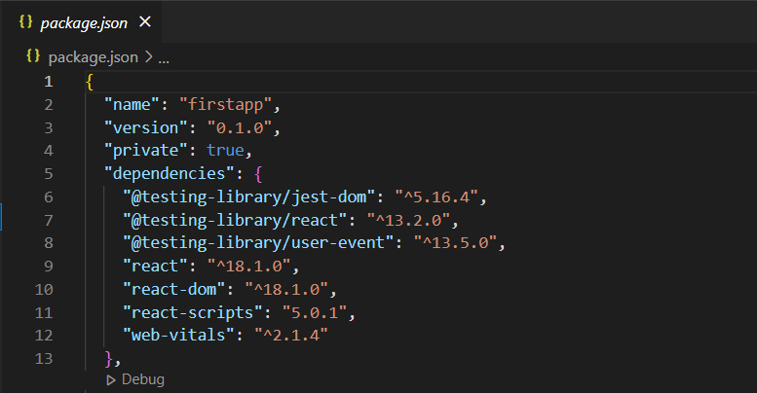
- 24/05/2022 (Tuesday)

On 2nd day started learning JavaScript. I learned the basic concept of JS like the methods of the array, DOM manipulation, inbuilt functions, map method, etc. also made a Digital clock using HTML CSS, and JS.

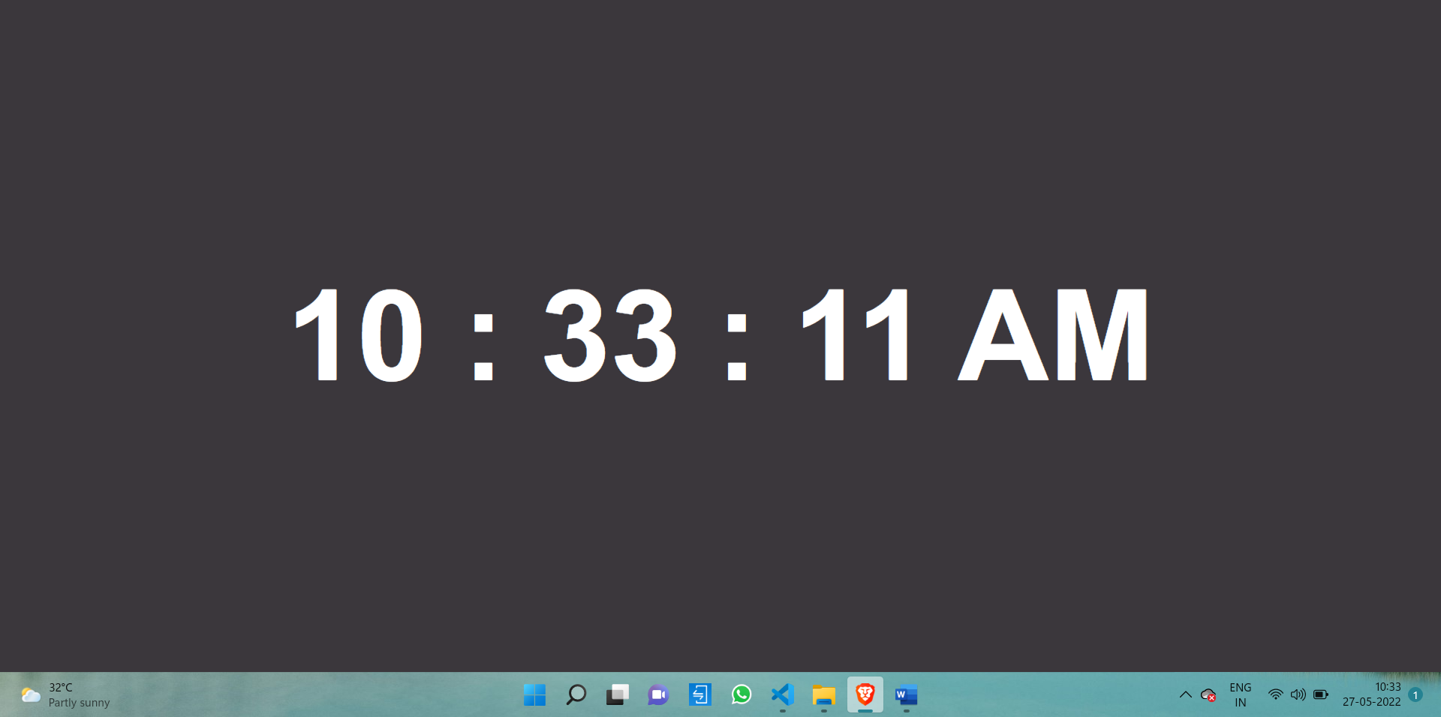

- 18/05/2022 (Wednesday)

Make a Calculator using HTML, CSS & JavaScript. Also done a task given by our external guide which is based on the basics of javascript.
The questions are here.

Code link: https://github.com/naitikp2002/Summer-Internship-I/tree/main/Day-3_JavaScriptTask/Calculator

Merge 3 arrays.
Remove 2 nd element from an array.
Replace 1st element of the array with the new value.
Find the max and min numbers from the array.
Sort array in descending order.
"Hello World !" . replace World with "ABC".
"Hello XYZ, " add "How are you" at the end of the string.
Declare one array with a number and sum all the numbers.

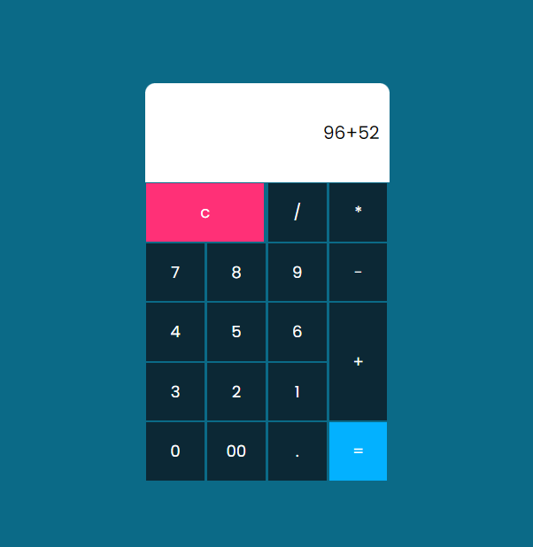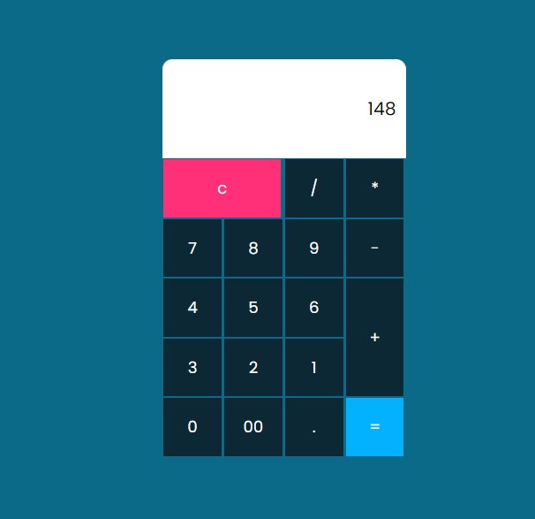

- 19/05/2022 (Thursday)

Created a Todo List website using HTML CSS & JS.
After adding tasks to remove if we click once on the task then it will be completed and if we click twice then it will be removed from the list.
https://github.com/naitikp2002/Summer-Internship-I/tree/main/Day-4_Js_Projects/To%20Do%20List

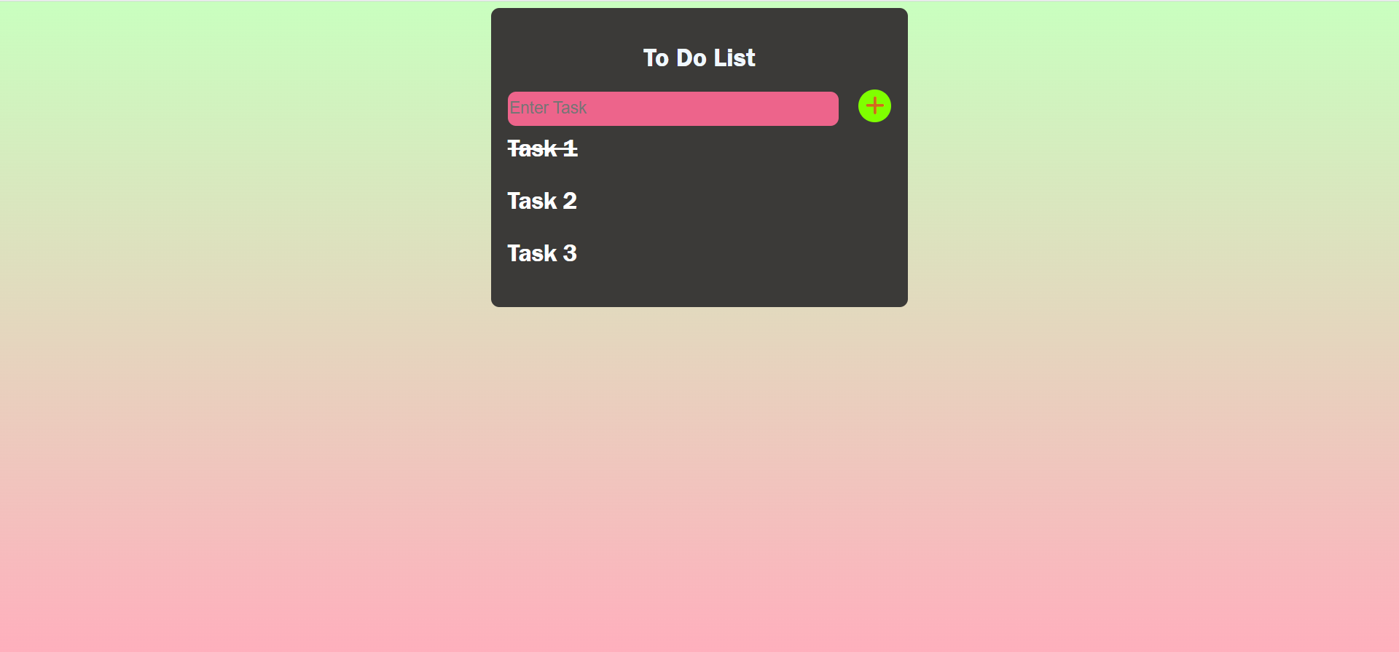

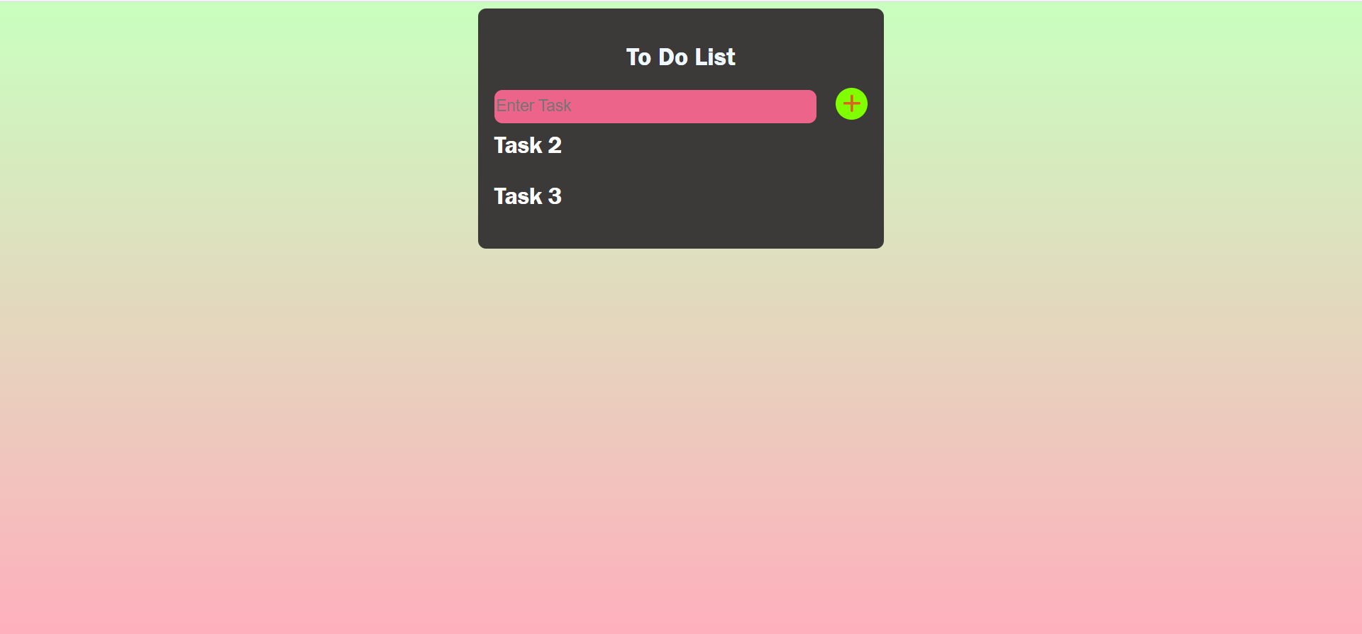

- 20/05/2022 (Friday)
Started learning ES6(EcmaScript-6) which is an updated version of JavaScript which is used in ReactJs.
Also, I learned how to create react app. Using this command I created react app:

npx create-react-app app_name
cd app_name
npm install
npm start

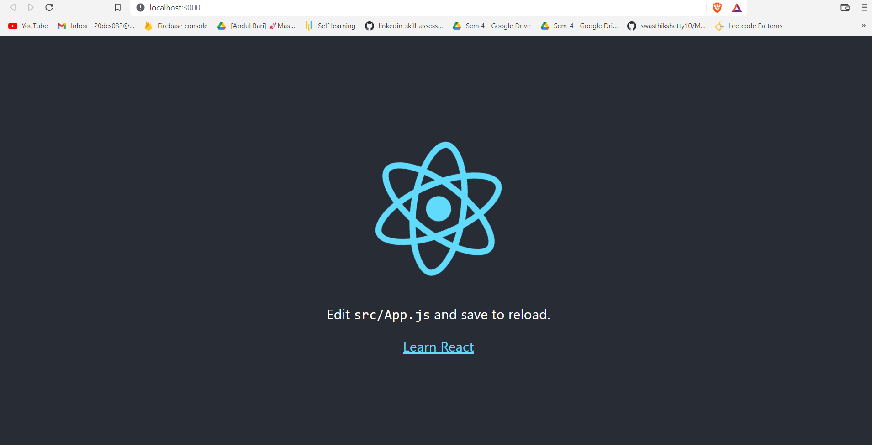

Plans for next week:

Learn basic concepts of reacting and make Calculator and Notes app using ReactJs.

References:

Signature of External Guide Signature of Internal Guide

